Hunter Cambridge

Ben Clay

Lynn Farrington

Ryan Parson – CS 240

Map Generation project

5/2/19

* **(5pts)** What progress have you made?

We have made design decisions, focusing on subterranean first. Use a “Tile based” Structure. We also debated whether using tiles to link to square footage link to rooms. We decided to use disjoint set to store the tile object and consolidate tiles into a map. We have also played around in javaFX learning the quirks and methods in order to import images, some of which we have already made, in order to bring the project to life.

* (**5pts)** What do you still have left to do?
  + Please provide a brief timeline for the pieces you have left to do (give specific dates you plan to accomplish these pieces by)

Time line:

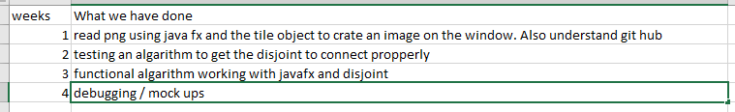

Learn more about disjoint set and logic requirement around how they interact with our pre existing code. Furthermore, we need to explore javaFX and how to properly arrange the images so that they line up on the “Snap joints”. We also need a program that combines tiles together to make a map. We also have to make lot more graphics.

* **(5pts)** How have you implemented/utilized concepts from this course? (list at least 1)

We have struggled. We have spent most of our time discussing tradeoffs between different data types. We plan on using disjoint and are trying to figure out which other data structures we will need.

* **(5pts)** Give two example of design decisions you have made and why you made those specific decisions

We made the decision to make the map “Tile” based, and we also decide to have the computer strictly generate the map rather than the user. The tile itself is square based instead of room based and finally, the graphics for the tiles are predawn in png(Subject to change)

* **(5pts)** Have you started testing your project? If so, how?

**Kinda, we have played around in javaFX trying to figure out how it works.**

You are to submit one report for your whole group with everyone's name on it. Make sure you work together to produce the report. The report with result in one portion of your grade for the mid-point check-in that will be given to all members of the group.